💊 PharmaEZ — Pharmacy & Healthcare E-Commerce
Phase | Project Design Phase II
Document | Technology Stack (Architecture & Stack)
Project Name | PharmaEZ — Pharmacy & Healthcare E-Commerce
Team ID | [TEAM-ID]
Date | 14 June 2026
Maximum Marks | 4 Marks

Technology Stack (Architecture & Stack)

Technical Architecture Overview
PharmaEZ follows a 3-tier MERN stack architecture: Presentation Layer (React.js SPA), Application Layer (Node.js + Express.js REST API), and Data Layer (MongoDB + Mongoose ODM).

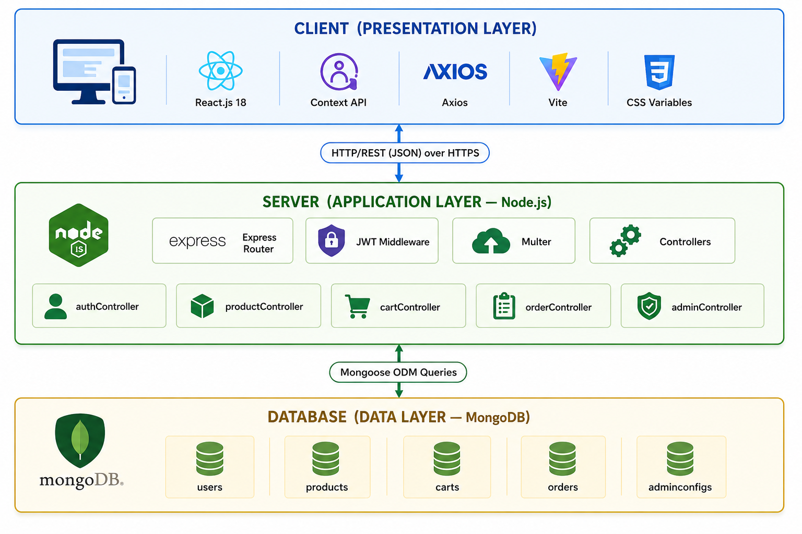

Table 1: Components & Technologies
S.No. | Component | Description | Technology
1 | User Interface | Web-based Single Page Application (SPA) that users interact with to browse products, upload prescriptions, manage cart, checkout, and track orders. Admin panel for pharmacy management. | React.js 18, React Router DOM v6, Context API, CSS Custom Variables, React Icons (Feather), React Hot Toast, Vite 5 (build tool)
2 | Application Logic — Auth | Handles user registration, login, JWT token generation and verification, role-based access control (user / admin), password hashing. | Node.js 18+, Express.js 4, jsonwebtoken 9, bcryptjs 2
3 | Application Logic — Products & Cart | Manages pharmacy product catalogue with full clinical metadata. Handles cart operations with stock validation, price snapshots, and real-time subtotal computation. | Express.js Controllers, Mongoose ODM, MongoDB regex queries for full-text search
4 | Application Logic — Orders | Orchestrates order placement (stock deduction, loyalty points), order tracking (status history audit trail), cancellation (stock restoration), and admin analytics aggregation. | Express.js Controllers, MongoDB Aggregation Pipeline, Mongoose pre-save hooks
5 | Application Logic — File Upload | Handles multipart prescription uploads (image/PDF) and product image uploads. Validates file type and size. | Multer 1.x, Node.js fs module, Local uploads/ directory
6 | Database | Primary data store for all application entities: users (with embedded addresses and prescriptions), products (with embedded reviews), carts, orders (with status history), and adminConfig (store settings and banners). | MongoDB 6+, Mongoose 8 (ODM), MongoDB Atlas (cloud) or Local MongoDB
7 | File Storage | Prescription files (JPG/PNG/PDF) and product images stored on local filesystem under uploads/. Served statically via Express. | Local filesystem (uploads/ directory), Express static middleware. Production: AWS S3 or Cloudinary (planned)
8 | Infrastructure (Server) | Backend Node.js application deployed as a long-running process. Frontend served as a static build or through the Vite dev server proxy during development. | Development: Nodemon + Vite dev server. Production: Railway / Render / AWS EC2, MongoDB Atlas, Nginx reverse proxy
9 | Security Layer | JWT token verification on protected routes, bcryptjs password hashing, CORS restriction to trusted origins, Multer file type filtering, global error handler masking internal details in production. | jsonwebtoken, bcryptjs, cors npm package, express-validator (input validation)
10 | HTTP Client (Frontend) | Axios instance with baseURL, request interceptor for automatic Bearer token injection, and response interceptor for global 401 handling and redirect to login. | Axios 1.x

Table 2: Application Characteristics
S.No. | Characteristic | Description | Technology Used
1 | Open-Source Frameworks | React.js (MIT), Express.js (MIT), Mongoose (MIT), Vite (MIT), Axios (MIT), React Router (MIT), bcryptjs (MIT), jsonwebtoken (MIT), Multer (MIT), React Icons (MIT), React Hot Toast (MIT). All dependencies are open-source with permissive licences — zero proprietary runtime dependency. | Node.js, React.js, Express.js, MongoDB Community Edition, Mongoose
2 | Security Implementations | Passwords hashed with bcryptjs (10 salt rounds — OWASP recommended). JWT tokens signed with HS256 algorithm (7-day expiry). CORS restricted to allowed origins only. Multer rejects non-image/PDF uploads. express-validator sanitises all API inputs. Global error handler strips stack traces in production mode. Bearer token stored in localStorage (client-side). Role-based access: protect + adminOnly middleware chain on all admin routes. | bcryptjs, jsonwebtoken (HS256), CORS, Multer file-type filter, express-validator
3 | Scalable Architecture | 3-tier architecture with clean MVC separation. Stateless JWT authentication enables horizontal scaling of the Node.js application tier. MongoDB supports horizontal sharding for the data tier. Modular controllers and route files (5 each) enable future microservice decomposition. Product schema supports multi-vendor extension. API versioned under /api/ prefix. | Stateless JWT, MongoDB Sharding, Modular MVC, Mongoose ODM
4 | Availability | MongoDB Atlas provides 99.95% uptime SLA with automatic primary failover and replica sets. Health check endpoint (GET /api/health) for uptime monitoring. process.exit(1) on DB connection failure prevents serving requests on a broken database. Static file uploads served directly by Express without additional service dependency. | MongoDB Atlas Replica Sets, Express Health Endpoint, Railway/Render auto-restart
5 | Performance | MongoDB indexed fields: email (unique index on users), product name/genericName/tags (used in regex queries). Pagination (limit/skip) on all list endpoints prevents over-fetching. Vite production build: code-splitting, tree-shaking, minification, and chunk optimisation. React Context prevents redundant API calls (cart and auth state cached in memory). Axios interceptors execute once, eliminating per-component token logic. | MongoDB Indexes, Mongoose skip/limit, Vite code-splitting, React Context caching

Full Dependency List
Package | Version | Layer | Purpose
react | ^18.2.0 | Frontend | UI component library — SPA rendering
react-dom | ^18.2.0 | Frontend | DOM rendering for React
react-router-dom | ^6.21.1 | Frontend | Client-side routing with protected routes
axios | ^1.6.2 | Frontend | HTTP client with interceptors
react-hot-toast | ^2.4.1 | Frontend | Toast notification system
react-icons | ^4.12.0 | Frontend | Feather icon set
vite | ^5.0.8 | Frontend Build | Development server and production bundler
@vitejs/plugin-react | ^4.2.1 | Frontend Build | React JSX transform for Vite
express | ^4.18.2 | Backend | Web framework and REST API routing
mongoose | ^8.0.3 | Backend | MongoDB ODM with schema validation
jsonwebtoken | ^9.0.2 | Backend | JWT token generation and verification
bcryptjs | ^2.4.3 | Backend | Password hashing (10 salt rounds)
multer | ^1.4.5-lts.1 | Backend | Multipart file upload handling
cors | ^2.8.5 | Backend | Cross-Origin Resource Sharing middleware
dotenv | ^16.3.1 | Backend | Environment variable loading from .env
express-validator | ^7.0.1 | Backend | API input validation and sanitisation
nodemon | ^3.0.2 | Backend Dev | Hot-reload for development server

